To: kiranjain@gmail.com, misaonakano@gmail.com
Subject: Canary cipher

Dear Kiran and Misao,

Introduction
I am writing this email to explain how encryption and decryption works in the Canary cipher. I will explain and justify the purpose of each step for the overall security using my handwritten working, block diagram, and SageMath results.

Encryption
First, I will be explaining the encryption process. Encryption is important because it plays a huge role in achieving confidentiality. Encryption prevents information that is intercepted by outsiders to be intelligible by scrambling the information. The information will be meaningless without a key that both the sender and receiver have. One round of the encryption process consists of three operations: bitwise exclusive or, 2-bit circular left shift, and 4-bit substitution.

One round of operations
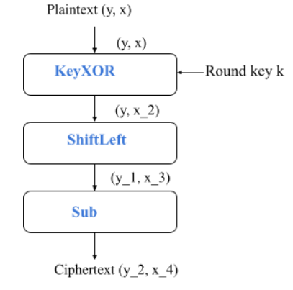

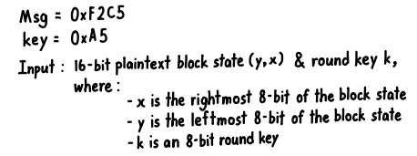
Operation 1: KeyXOR
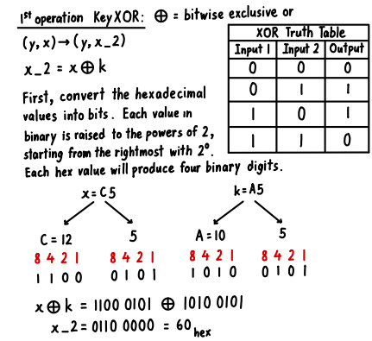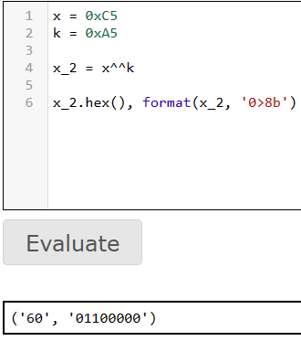
^^ = XOR
As observed from the handwritten and SageMath results, the result for x_2 is 60H or 0110 0000B. This step introduces a layer of confidentiality that is key recovery (KR). This is because it is practically impossible for an attacker to obtain or guess the key.
Operation 2: ShiftLeft
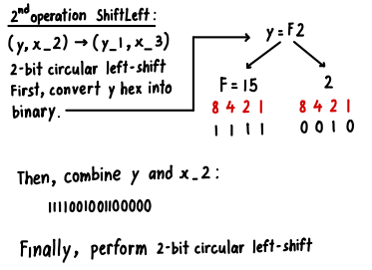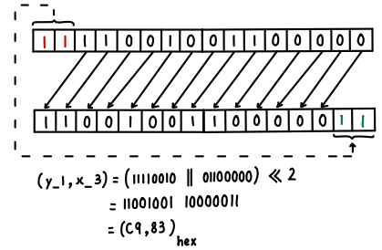
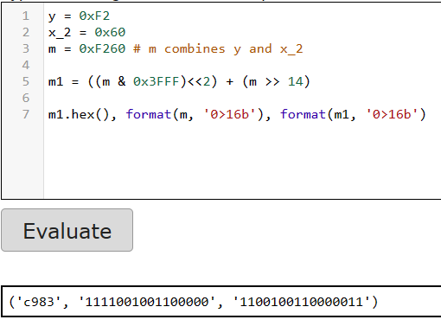
Shift left by 2-bits

By shifting the digits of (y, x_2) by 2-bits, the value obtained is C983H or 1100100110000011B. This step achieves both plaintext recovery (PR) and indistinguishability (IND) as the attacker will not be able to comprehend how many bits to shift the relatively large 16-bits message.

Operation 3: Sub
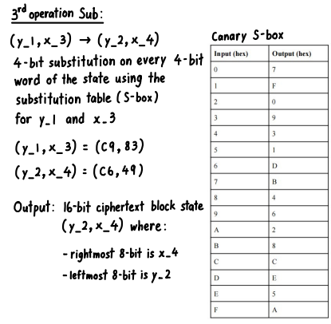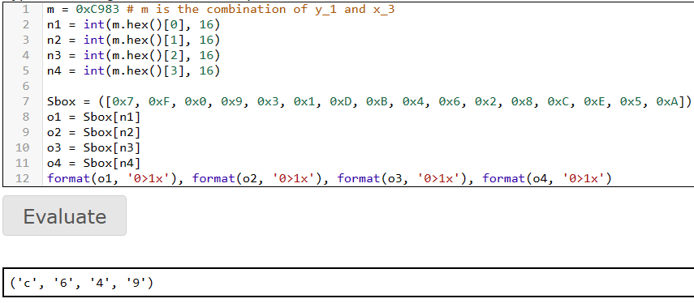
Index is 0, 1, …, F. (e.g. 0 = 7, 1 = F, 15 = A)
Utilizing the Substitution table (S-box), the inputs are compared to their corresponding outputs to produce the result. (y_2, x_4) = C649H or 1100011001001001B. This step also achieves indistinguishability (IND) as the attacker would not know how the substitution table is organised.

Encryption Conclusion
With the initial message of (y, x) = F2C5H and the key = A5H, the message has been encrypted to (y_2, x_4) = C649H. Through these operations with layers of confidentiality, it would be difficult for an attacker to easily intercept the message.

Decryption
Now that the message is encrypted, it will be difficult for outsiders to intercept the message. The receiver, however, with the same key and knowledge of the operations as the sender, can reverse the encryption process to decrypt the message.

One round of operations
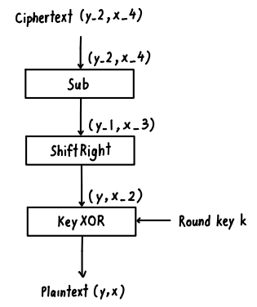

Operation 1: Sub
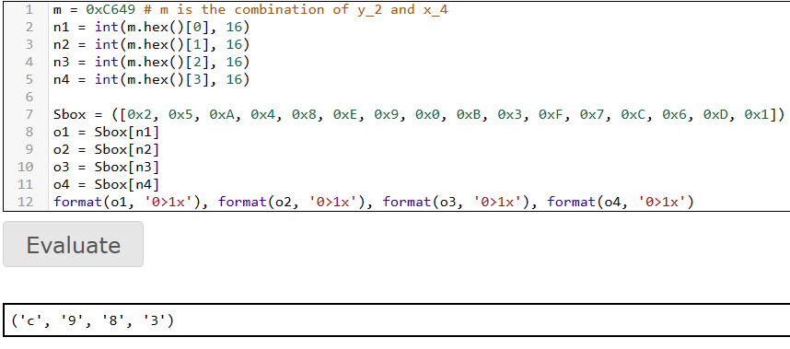
e.g. ShiftLeft: 0 = 7, 14 = 5 | ShiftRight: 7 = 0, 5 = E
The inputs and outputs of the S-box are swapped
Utilizing the same table as before but swapping the input and outputs, the encrypted message goes through the same process in reverse to obtain C983H.

Operation 2: ShiftRight
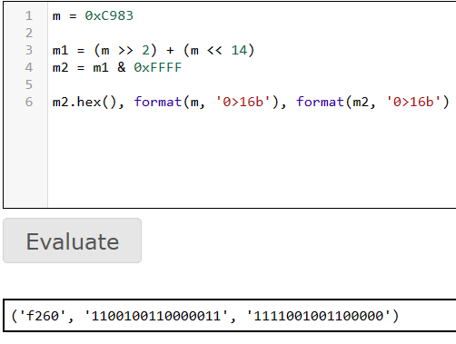
Shift right by 2-bits
By shifting the digits to the right by 2-bits. (y, x_2) = F260H can be obtained.

Operation 3: KeyXOR
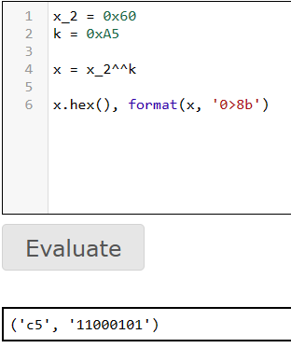
By using the same key as the sender, x_2 XOR k will result in x = C5.

Decryption Conclusion
After going through the operations with the same key as the sender, A5H, the encrypted message, C649H, has been decrypted to the original message, F2C5H.

Conclusion
To summarise, the Canary cipher utilises a key and undergoes three operations: bitwise exclusive or, 2-bit circular left shift, and 4-bit substitution, to encrypt messages. Only by knowing the key and the method to reverse the operations, can the encrypted message be decrypted to reveal the original message. I hope you find this email helpful in understanding how the Canary cipher works.

Regards,
Braden

